

Integration Requirements

Promotions Interface from ORMS10 to GFO

Author: Heather Rennoldson

Version: 0.2

Date: 22/02/2007

Status: Draft

Table of Contents
1. Introduction 4
1.1 Background 4
1.2 Issues 4
2. Promotions on ORMS10 5
2.1 Overview 5
2.2 Processing within ORMS10 6
3. Requirements 7
3.1 GFO requirements 7
3.2 Assumptions 7
3.3 Logic for extracting from ORMS10 7
3.4 Additional notes 8
Appendix A Promotions File Mappings 9
Appendix B Glossary of Terms 10

Document Control

Project: | Operating Model – Integration
Document Title: | Requirements Definition
Document Location: | Docshare
Distribution: | Lewis Stewart  Nuno Carvalho  Miles Thomas  Adrian Hinks  Allistair Green  Nikhil Rajwade | GFO  )  )  )TOM Integration team  )  )

Change Record

Date | Version | Change Description | Author
09/02/2007 | 0.1 | Initial Draft | Heather Rennoldson
22/02/2007 | 0.2 | Department promotions will not be identified as a separate category on the final output file | Heather  Rennoldson

References

Document | Version | Date | Author

Introduction

Background

The purpose of this document is to confirm the business requirements for the promotions interface from ORMS10 to Group, Forecast & Order (GFO) for Turkey. The information is based on the requirements for the GFO Promotions Interface file mappings (see Appendix A) and conversations with the GFO team.

This covers the requirements for the interfaces C010TR (Promotion Data ORMS10 to GFO). Promotions data from ORMS10 (as in Turkey) will not be persisted in the Integration Data Store (IDS).

Promotions are structured in a different manner within ORPM12, so the GFO requirements for this data will be documented separately, although the ultimate receiving file/table will be the same. In this case promotions will be persisted in the IDS. This is covered by interfaces C010US and J114.

Promotions on ORMS10

Overview

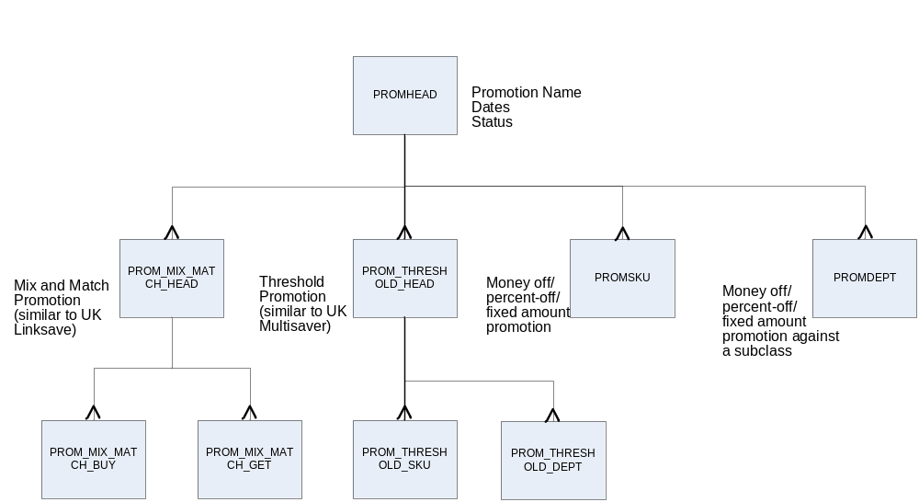

The diagram above portrays how ORMS10 holds promotion details within its tables.
Note: only tables pertinent to the GFO requirements are shown.

Table | Description
PROMHEAD | This holds the major promotional information – promotion, promotion_name, start and end dates. A promotion can be one of 4 types – mix match (aka buy-get), threshold, simple, departmental
PROM_MIX_MATCH_HEAD | This describes the mix/match promotion. In ORMS terms there is a ‘buy list’ and a ‘get list’ and the customer has to buy any or all the items in the ‘buy list’ to get a discount on the items in the ‘get list’. This is similar to the UK Linksave promotion.
PROM_MIX_MATCH_BUY | This contains the ITEM (base product) in the buy list
PROM_MIX_MATCH_GET | This contains the ITEM (base product) in the get list
PROM_THRESHOLD_HEAD | In this promotion type the customer has to purchase a threshold number of a product to obtain a discount. This can be at product or at departmental level.  This is similar to the UK Multisaver.
PROM_THRESHOLD_SKU | This contains the SKUs in the threshold promotion
PROM_THRESHOLD_DEPT | This contains the department or class or subclass included in a threshold promotion – and will therefore apply to all products in that grouping.  This is not being used in Turkey, since it does not map to the Storeline view of promotions.
PROMSKU | This is used for a simple promotion – money off, percentage off or fixed price promotion and this table contains all the ITEMs included in that promotion.
PROMDEPT | This is also used for a simple promotion – and is linked to all items in the subclass

Processing within ORMS10

Departmental promotions
Unlike UK subgroup promotions, the departmental promotions (PROMDEPT and PROM_THRESHOLD_DEPT) are cascaded to item level before the promotion is downloaded to the Point of Sale system. This normally happens on the day that the promotions information is transmitted to the POS system.

This results in the PROM_THRESOLD_SKU and PROMSKU tables, respectively, being populated with the details, but the PROM_THRESHOLD_DEPT and PROMDEPT tables will still exist alongside.

Having exploded the departmental promotions to item level, it is not possible for the user to subsequently update the PROMDEPT and PROM_THRESHOLD_DEPT tables. Any amendments by the user are mad to the PROMSKU table.
(Note that Turkey does not use the PROM_THRESHOLD_DEPT promotions).

Promotion Status
The promotion can move through different statuses:
- W=Worksheet
- S=Submitted (for approval)
- A=Approved
- R=Rejected (after being submitted)
- C=Cancelled
- D=Deleted (to be deleted)
- M =Completed
- E=Extracted
- I = submittal, approval in progress

Promotions can swap from approved back to worksheet status, ahead of the promotion being extracted.

Linking promotions to stores (not pertinent for ORMS10 to GFO – just for information)
Having defined the promotion ORMS10 can then link it to a group of stores. This information is captured in the PROMSTORE table, and then this is used in the POS download process.

The start and end dates for the promotion can be changed at the promotion-store level, but must fall within the overall promotion start and end dates.

Requirements

GFO requirements
1. GFO require a Promotions interface provided daily (probably c 2200hrs but requires confirmation).

2. This will contain details of all SKUs on promotion currently and at any time in the next 31 days.
GFO are only interested in promotions in the approved or executed status.

3. GFO requires that departmental promotions are expanded to the SKU level on this interface.

4. GFO requires a complete file every day – not deltas.

Assumptions
Within ORMS, it appears to be possible for a promotion to include different promotion types e.g. PROMSKU and PROM_MIX_MATCH_HEAD can be held under the same PROMHEAD. In this design, it has been assumed that the business do not mix promotions of different types under the same header.

It is also possible for the PROMSKU, PROM_MIX_MATCH_GET_ITEM, and PROM_MIX_MATCH_BUY_ITEM to be linked to a transaction level item or the parent SKU item level (i.e. Style) with / without a DIFF specified. For example, at a transaction level, the user would select Red, Size 10 T shirt, at Style / Diff, the user would select Red T-shirt (and then all the different sizes for the red T shirt would be included in the promotions) and Style level the user would select ‘T shirt’ (and all colour/size combinations would be included). It is again assumed that the business only link to the transaction level item.

Logic for extracting from ORMS10

- Extract all PROMHEAD .PROMOTION, PROMHEAD.PROM_NAME, PROMHEAD.START_DATE and PROMHEAD.END.DATE where PROMHEAD.START_DATE is <= control date + 31 days and PROMHEAD.END_DATE is >= control date and PROMHEAD.STATUS = ‘A’ (approved) or ‘E’ (extracted).
(I assume that the control date will actually be ‘tomorrow’, since GFO is receiving a file tonight for action tomorrow)
.
The following paragraphs indicate how to identify the items in the promotion;

- Match PROMHEAD.PROMOTION against PROM_THRESHOLD_SKU.PROMOTION, and PROM_THRESHOLD_SKU.ITEM respectively.
Note:
  - there won’t always be an entry in this table
  - this promotion is a ‘Threshold’ promotion.

- Similarly, match PROMHEAD.PROMOTION against PROM_MIX_MATCH_BUY.PROMOTION, and PROM_MIX_MATCH_GET.PROMOTION and extract PROM_MIX_MATCH_BUY.ITEM and PROM_MIX_MATCH_GET.ITEM respectively.
Note:
  - there won’t always be an entry in these tables
  - this promotion is a ‘Buy-Get’ promotion.

- Then match PROMHEAD.PROMOTION against PROMDEPT.PROMOTION. For any matches, check for the existence of the same promotions in the PROMSKU tables. This promotion is a ‘simple’ promotion.

    - If a match is found here, it can be assumed that the department promotion has already been exploded to the item level, so capture all PROMSKU.ITEM.
    - If no match is found, the departments in the promotion need to be exploded to the transaction items. This will be achieved by matching: the DEPT, CLASS and SUBCLASS on the PROMDEPT table against the same fields on ITEM_MASTER, where ITEM_MASTER.ITEM_LEVEL = 2 and PACK_IND = N. The ITEM_MASTER.ITEM fields will be the sellable transaction level items within the subclass.

- Then match PROMHEAD.PROMOTION against PROMSKU.PROMOTION (but exclude any promotions which have already been identified as departmental promotions above), and extract all PROMSKU.ITEM. This promotion is a ‘simple’ promotion.

Additional notes
Since a promotion can transfer from approved back to worksheet status, it is possible that a promotion will disappear from the file, before the promotion is extracted.

- Promotions File Mappings

GFO Integration Layer Promotions File |  |  |  |  |  | ORMS10 Source
Data Item | Data Type | Data Length | Fixed Data | Data Format |  | Table | Data Item | Data Type | Data Length | Notes?
JIPMA-RECORD-TYPE | NUMERIC | 2 | "00"
JIPMA-DATE | CHAR |  |  | CCYYMMDD
FILLER | CHAR |  | SPACES
JIPMB-RECORD-TYPE | NUMERIC | 2 | "01"
JIPMB-BASE-PRODUCT-NO | CHAR | 9 |  |  |  | Various.  See section 3 | ITEM | VARCHAR2 | 25
FILLER | NUMERIC | 5 | ZEROES
FILLER | CHAR | 1 | SPACES
JIPMB-PROMOTION-START | NUMERIC | 8 |  | CCYYMMDD |  | PROMHEAD | START_DATE | DATE | ?
JIPMB-PROM-END-DATE | NUMERIC | 8 |  | CCYYMMDD |  | PROMHEAD | END_DATE | DATE | ?
JIPMB-BPR-UPLIFT-PERC | NUMERIC | 8 | ZEROES | +/-9999999
FILLER | CHAR | 1 | SPACES
FILLER | CHAR | 48 | SPACES
JIPMB-OFFER-ID | CHAR | 9 |  |  |  | PROMHEAD | PROMOTION | NUMBER | 10
JIPMB-OFFER-DESC | CHAR | 50 |  |  |  | PROMHEAD | NAME | VARCHAR2 | 40
JIPMB-OFFER-BUKT-REQD | CHAR | 1 |  |  |  | ? | ? | ? | ? | Will be set to ‘N’
JIPMB-FEATURE-SPCE-DISP | CHAR | 1 | "Y"
JIPMB-BPR-REGN | CHAR | 2 | "00"
JIPMB-AREA-CD | CHAR | 1 | "1"
JIPMB-OFFER-TYPE | CHAR | 3 |  |  |  | ? | ? | ? | ? | Buy-get, threshold or simple.  GFO team to specify the mnemonic required.
FILLER | CHAR | 84 | SPACES
JIPMZ-RECORD-TYPE | NUMERIC | 2 | "99"
FILLER | CHAR | 241 | SPACES
JIPMZ-REC-COUNT | NUMERIC | 7

- Glossary of Terms

Mnemonic | Description
GFO | Group Forecast & Order
IDS | Integration Data Store
ORMS | Oracle Retail Management System
ORPM | Oracle Retail Price Management
POS | Point of Sale
RIB | Retek Integration Bus

